RETAIL MANAGEMENT APPLICATION USING SALSEFORCE

**Milestone-1 :**

**Introduction**

Are you new to Salesforce? Not sure exactly what it is, or how to use it? Don’t know where

you should start on your learning journey? If you’ve answered yes to any of these questions,

then you’re in the right place. This module is for you.

Welcome to Salesforce! Salesforce is game-changing technology, with a host of

productivity-boosting features, that will help you sell smarter and faster. As you work toward

your badge for this module, we’ll take you through these features and answer the question,

“What is Salesforce, anyway?”

**Activity**

**Creating Developer Account**

Creating a developer org in salesforce.

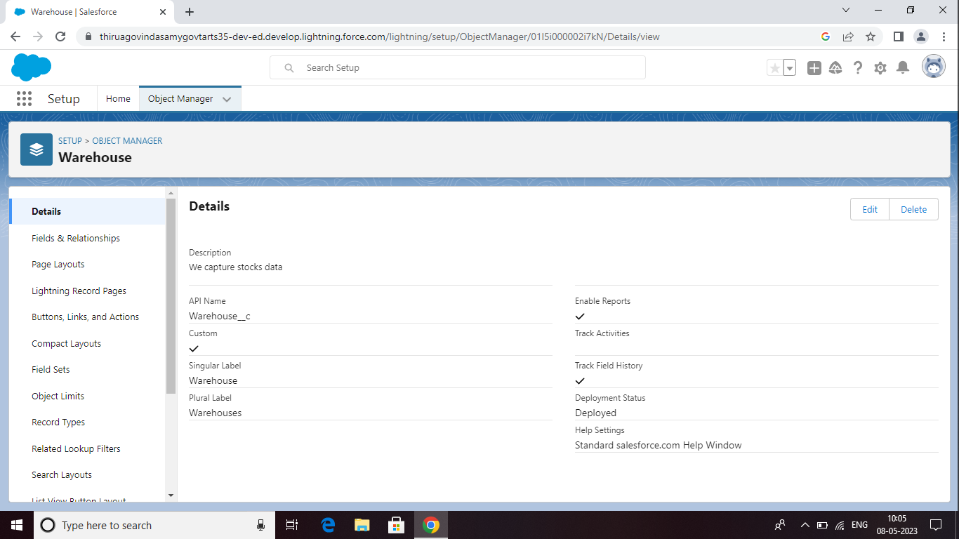

**Milestone-2 Objects:**

Objects are database tables that permit you to store data that is specific to an

Organization .Salesforce objects are of two types: 1) Standard objects,2) Custom objects



**Activity-1**

**Creation of object Dispatch/Tracking**

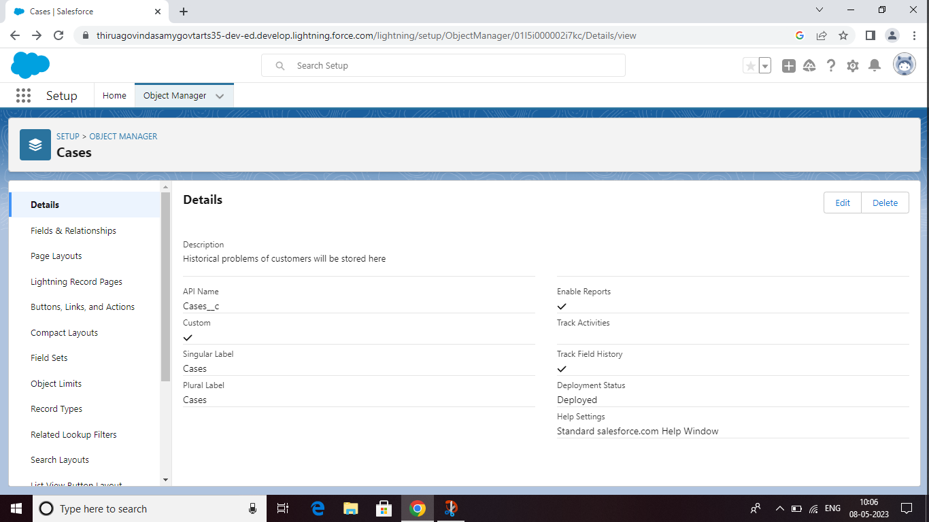

**Activity-2 Fields available on Dispatch/tracking**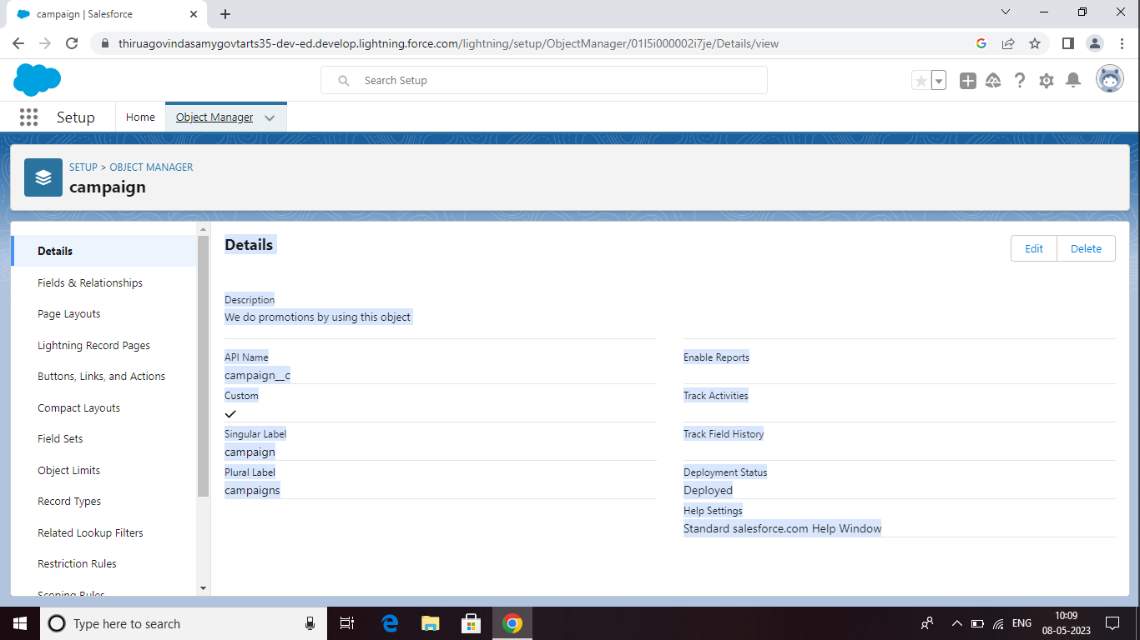

**Milestone-3 Relationship b/w objects:**

It's time to take things to the next level with object relationships. Object relationships are special

field types that connect two objects. As a crm product owner create relationships to link objects

with each other, so that when users view records, they can also see related data.

**Activity-1:**

**Creation of relationships between objects**

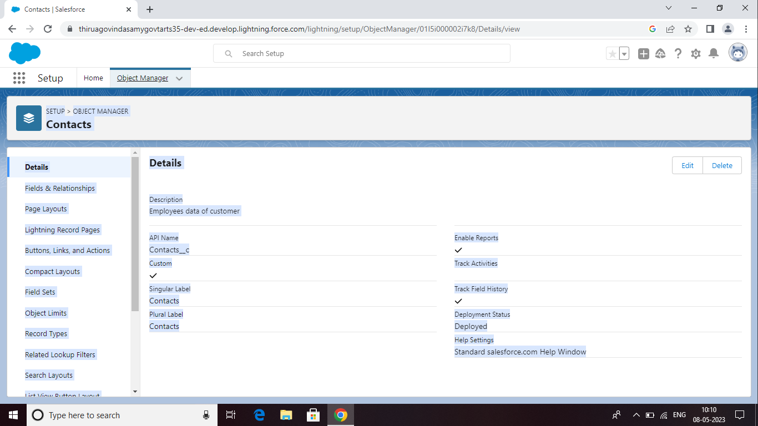

**Milestone-4 Application:**

**Apps in Salesforce** are a group of tabs that help the application function by working together as a unit. It

has a name, a logo, and a particular An app is a collection of items that work together to serve a

particular function. Salesforce apps come in two flavors: Classic and Lightning.

**Activity-1**

**Creation of Application**

1) Navigate to setup and search for app manager

2) And select an option for a new lightning app.

3) Give

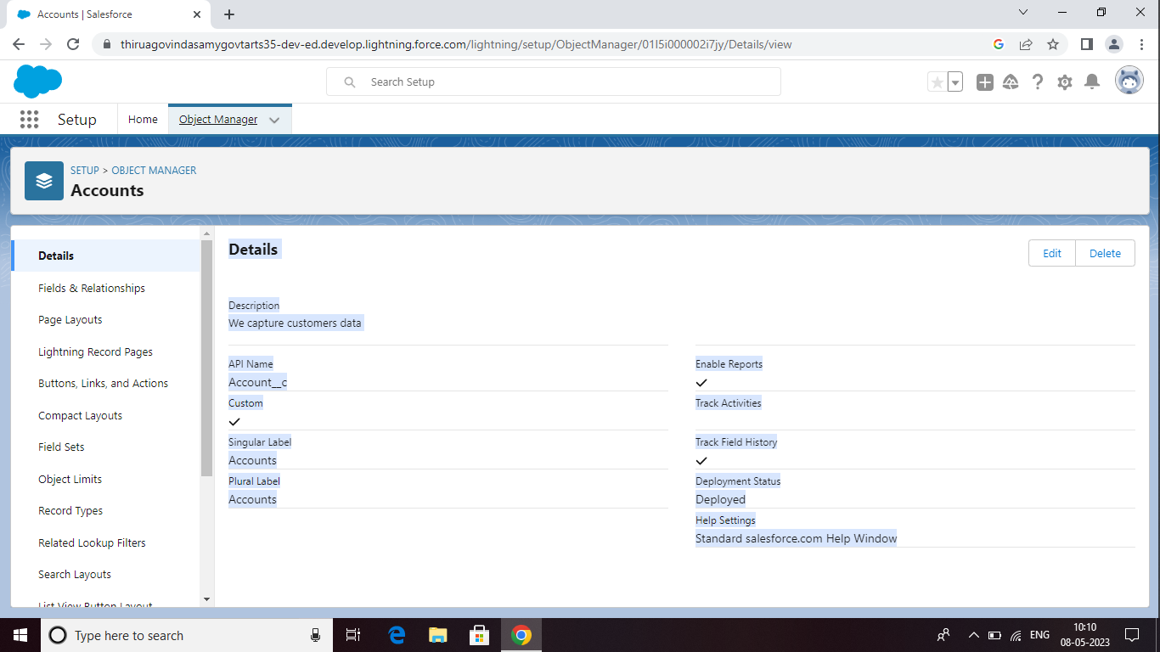

**Milestone-5 Layouts:**

Page layouts control the layout of an object, As a crm product owner create custom page layouts

which defines which fields the user can view and edit while entering data in objects. And must

contain different sets of fields and related lists.

Custom Page layouts

1) Warehouse page layout

2) Sales order layout

3) Dispatch/Tracking layout

**Activity-1:**

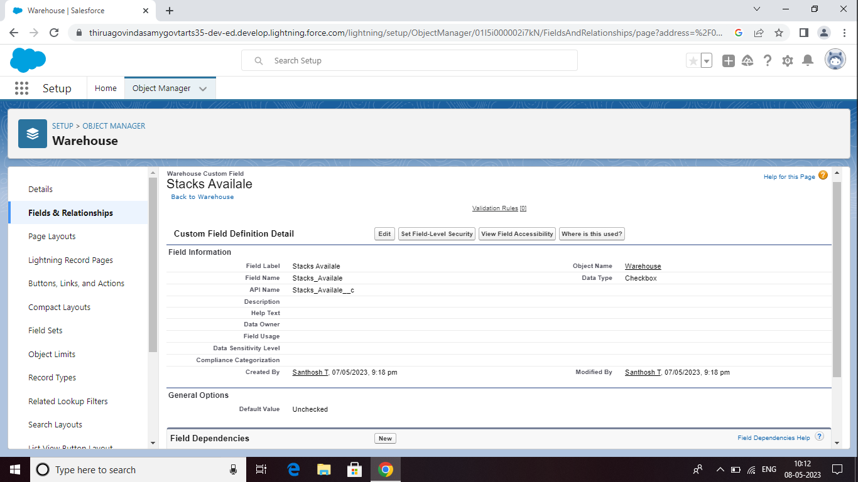

**Milestone-5 Layouts:**

Page layouts control the layout of an object, As a crm product owner create custom page layouts

which defines which fields the user can view and edit while entering data in objects. And must

contain different sets of fields and related lists.

Custom Page layouts

1) Warehouse page layout

2) Sales order layout

3) Dispatch/Tracking layout

**Activity-1:**

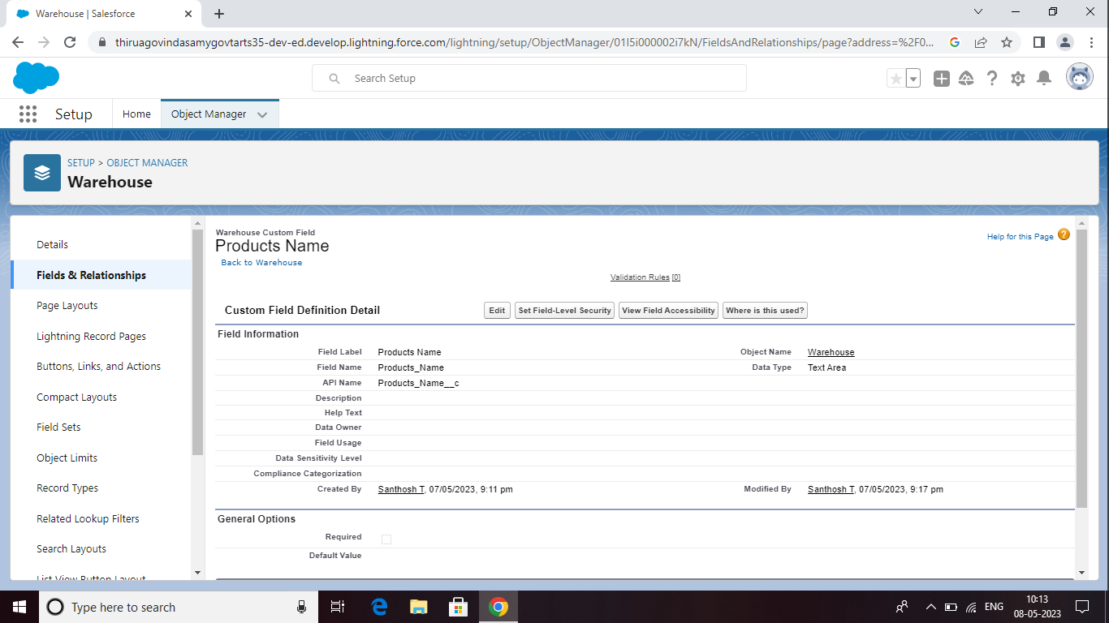

**Milestone-7 Validation Rules:**

Validation rules verify that the data a user enters in a record meets the standards you specify

before the user can save the record. As a crm product owner they requested to create a validation

rule on account object on the phone field.

**Activity-1**

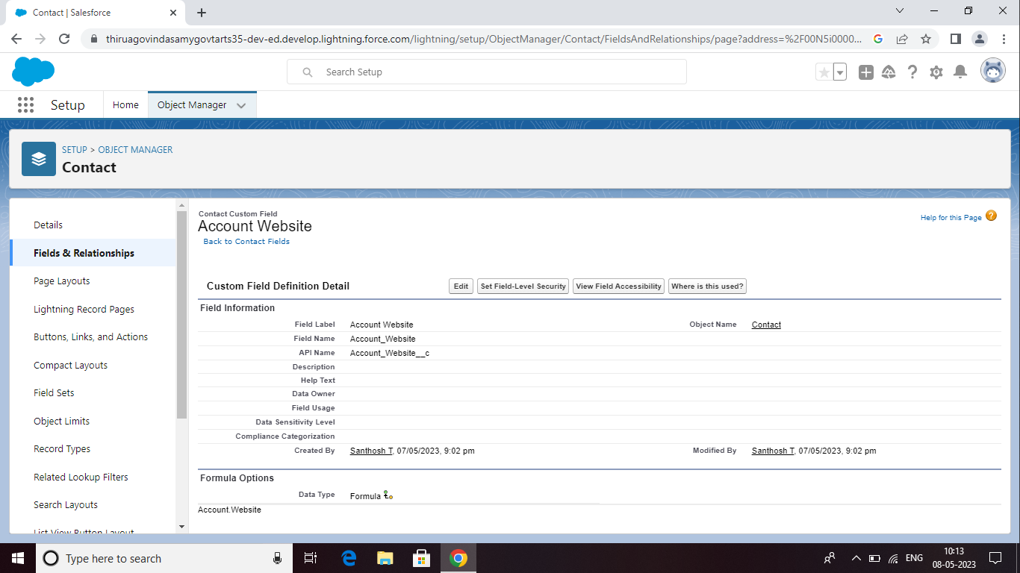

**Activity-2 :**

**Cross Object Formula**

Using an object formula lets you reference merge fields on a master object from a master detail

relationship on the detail object. As a crm product owner they wants to save user’s clicks and

displays contacts' parent accounts website value on the contact record so users do not have to

click on the account to find the website.

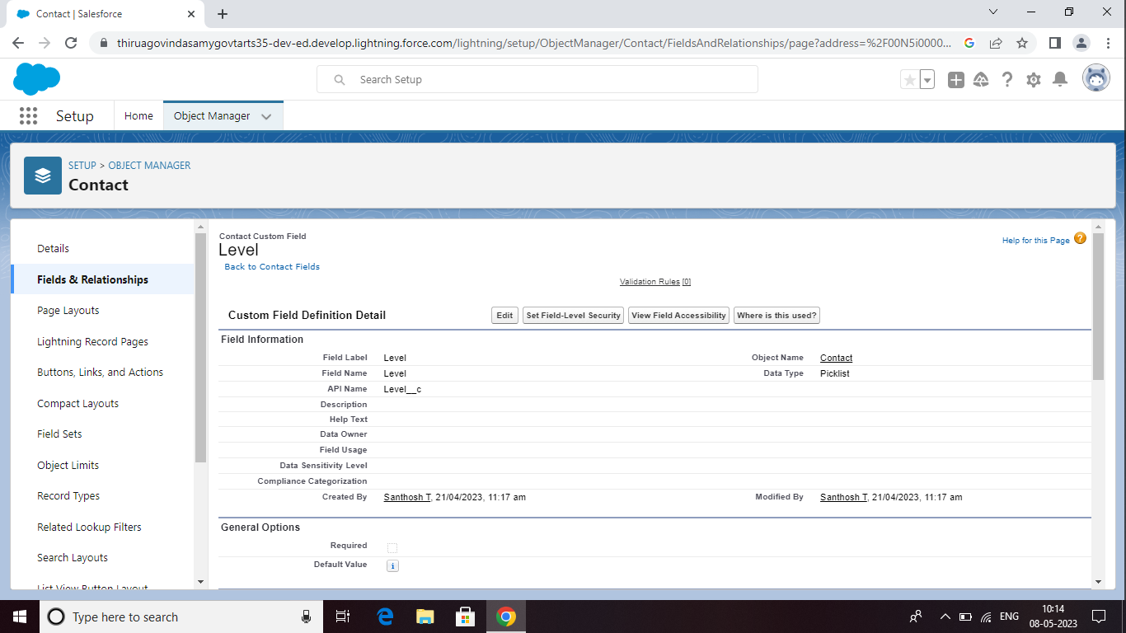**:**

**Milestone-7 Reports :**

A report is a list of records that meet the criteria you define. It's displayed in Salesforce in rows

and columns, and can be filtered, grouped, or displayed in a graphical chart. Every report is

stored in a folder. Folders can be public, hidden, or shared, and can be set to read-only or

read/write.

**Activity:**

**Creation of report**

Note- While creation of report ensure that update preview automatically is selected which is

available at the right side of the report page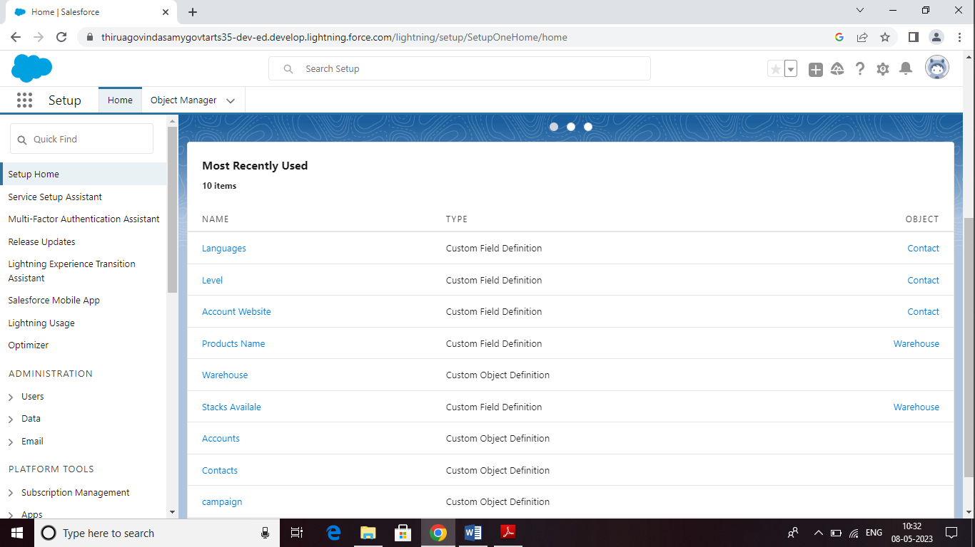

CONCLUATION;

To created new object and fields retail management application using salesforce is user friendly and cost effective system it is customised with activities related to retail management application using salseforce

Team leader santhosh (<https://trailblazer.me/id/tsanthosh9>)

Team members Sathish Kumar (<https://trailblazer.me/id/cchena10>)

Team members soundharya( <https://trailblazer.me/id/ssathish58>

Team members selvi(<https://trailblazer.me/id/screat68>)